**RA PATHOGENESIS**

Inflammation and swelling of the synovial membrane, or synovitis, are the pathological features of RA. Various immune modulators (cytokines and effector cells) and signalling pathways are involved in the pathophysiology of RA. Synovitis is caused by the influx or local activation, or both, of mononuclear cells (including T cells, B cells, plasma cells, APCs) and by angiogenesis. The osteoclast-rich portion of the synovial membrane, or pannus, destroys bone, whereas enzymes secreted by synoviocytes and chondrocytes degrade cartilage.

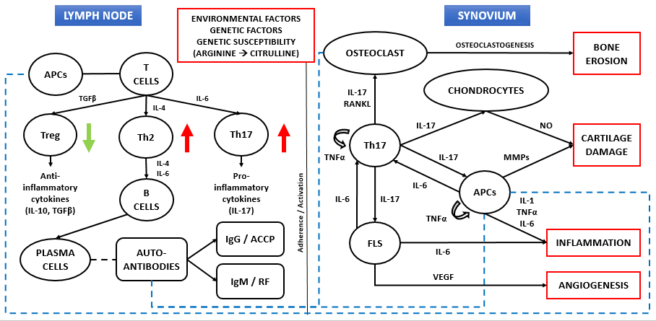

The genetic and environmental risk factors can lead to post-transcriptional modification of proteins in the synovium which leads to citrullination of proteins in the joint. These citrullinated peptides are then presented by APCs. APCs migrate to the central lymphoid organs to present antigen and activate T cells, which results in different subsets of effector cells Th2, Th17 and Tregs depending on the inducing cytokines.

Presence of IL-4 favours generation of Th2 lymphocytes, which synthesize IL-4 and IL-6 that helps in B-cell proliferation and antibody production, and also T-cell proliferation and differentiation. These lymphocytes and antibodies can migrate back to the synovium and enhance adaptive immune responses in the target cells like FLS, osteoclasts, APCs and other immune regulators by activating their proliferation and cytokine release. Treg cells produces of several anti- inflammatory cytokines such as TGF-β and IL-10. TGF-β is considered to have both pro- and anti- inflammatory roles. Anti-inflammatory: in the absence of IL-6, promotes the differentiation and proliferation of Treg cells and inhibits activation of TNF-α, APCs, and antibody production. Proinflammatory: chemotactic to FLS, promotes FLS proliferation, and the stability of Th17 cells. Defects in Treg cell number and/or function may contribute to loss of peripheral self-tolerance, leading to development of autoimmune diseases. Also, TNF-α is the central regulator of the immunity which autocrinally and paracrinally repress the expression of other cytokines, such as IL-1 and IL-6. TNF-α stimulates the proliferation and differentiation of B- and T-lymphocytes. As high levels of TNF-α are found in RA, this may result in defective Treg function by affecting signalling pathway. Differentiation of Th17 cells is mainly induced by IL-6 and synthesises IL-17, which contribute to the release of other pro-inflammatory mediators such as TNF-α, IL-1, IL-6 and MMPs by stimulating FLS, osteoblasts, chondrocytes and APCs.

B cells helps in antigen presentation, production of antibodies, autoantibodies and cytokines. Several autoantibodies can be detected in serum of RA patients, of which Rheumatoid Factor (RF) and Anti-Citrullinated Protein Antibodies (ACPA) are antibody isotypes IgM and IgG, respectively directed against these citrullinated peptides are detected in RA. Most of the pathological functions of autoantibodies in course of disease have been traditionally attributed to IgGs (APCs activation through FcR engagement) and IgMs (complement activation) which migrate to the synovium. Also, ACPAs can directly activate monocytes by binding through their Fab variable portion to a citrullinated GRP78 cell-surface receptor, driving NF-kB activation, and cytokine production that is increased in the presence of RF of the IgM and IgA classes, suggesting a synergism between ACPA and RF. Autoantibodies can initiate inflammatory effector pathways, which affect chondrocytes and the cartilage causing release of extracellular matrix (ECM) components.

Fibroblast-Like Synoviocytes (FLS) are present within the synovial membrane. In RA, the dysfunction of FLS leads to hyperplastic synovium. The growth and activation of FLS is autocrinally stimulated by production of TNFα and IL-6. IL-17 is one of the crucial factors in transforming FLS into an invasive RA-FLS type and may directly assist in FLS-mediated progression of RA. Therefore, these cytokines activate FLS, in the synovium leading to hyperproliferation and the consequential formation of an abnormal layer of fibrovascular tissue called pannus. Activated FLS also produces many bioactive substances including MMP, RANKL and VEGF. These, in turn, generate arthritic symptoms including joint pain, swelling, bone erosion, angiogenesis and cartilage destruction. The pannus expresses the cytokine receptor activator of nuclear factor kappa-β ligand (RANKL) which together with the APCs-released cytokines, stimulate the differentiation of osteoclast to resorb the calcified bone matrix (i.e. bone erosion). MMPs are promote disassembly of the type II collagen network causing biomechanical dysfunction. Increased IL-6 production from the FLS, may also induce Treg conversion to IL-17 producing cells or inhibit Treg suppression.

Osteoclasts constitute of the only cell type that is able to degrade bone. In healthy, bone resorption by osteoclasts and bone generation by osteoblasts are tightly regulated to maintain skeletal integrity and homeostasis. Evidence for the traditional inflammatory theory is as follows: TNF-α, IL-6, IL-17 involved in RA could exert pro-osteoclastogenic effects and suppress bone formation in the appropriate environment via adequate signals, such as the receptor activator of nuclear factor kappa-B ligand (RANKL). The second possible pathway for bone loss in RA involves two mechanisms for autoimmunity. The first mechanism pertains to the formation of immune complex and Fc-receptor-mediated osteoclast differentiation. The second is the formation of anti-citrullinated vimentin antibodies against the most citrullinated protein, making osteoclasts the ideal antigenic targets for ACPA. It is reported that ACPA binding to osteoclast precursors induces osteoclastogenesis, bone resorption, and bone loss.

Cartilage acts as a key component of synovial joints, consisting of Chondrocytes. Chondrocytes are unique to the articular cartilage, which maintain an equilibrium between synthesis and breakdown of extracellular matrix under physiological conditions. Cytokines trigger chondrocytes to release more cytokines and matrix metalloproteinases (MMPs) that can degrade the cartilage and also inhibit generation of tissue inhibitors of metalloproteinases (TIMPs). Consequently, under the influence of synovial cytokines, particularly IL-17, and NO, the cartilage is progressively deprived of chondrocytes that undergo apoptosis.

|  |  |  |  |
| --- | --- | --- | --- |
| **Cytokine** | **Source** | **Pathogenic role** | **Affected cells** |
| **TGF-β** | APCs, T cell (Tregs: major source), FLS | LYMPH NODE   * Anti-inflammatory: in the absence of IL-6, promotes the differentiation and proliferation of Treg cells and inhibits activation of TNF-α, APCs, and antibody production.   SYNOVIUM   * Proinflammatory: chemotactic to fibroblasts, promotes FLS proliferation, and the stability of Th17 cells. | FLS, Th17 cell, Treg cell, and APCs |
| **IL-4** | Th2 cell (major source), APCs | LYMPH NODE   * directs B cells to produce antibodies like lgG1 and lgE * promotes the expansion of Th2 cells   SYNOVIUM   * Inhibits the production of MMPs, IL-6, IL-17, and TNF-α | B cell, T cell, chondrocyte, FLS, osteoclast, and APC |
| **IL-6** | FLS (major source), Osteoblast, T cell, B cell | LYMPH NODE   * B-cell proliferation and antibody production * T-cell proliferation and differentiation   SYNOVIUM   * Pannus formation via promotion of VEGF production causing angiogenesis * Activates leukocytes and osteoclasts * Enhances the effects of IL-1 and TNFα * Maintains differentiation and homeostasis of Th17 cells * Triggers synthesis of acute-phase proteins * Induces synovial neovascularization. | Th17 cell, B cell, osteoclast, APCs, and synoviocytes |
| **IL-17** | Th17 cell (major source) | SYNOVIUM   * Increased synovial fibroblast cytokine release, osteoclastogenesis and cartilage damage * Stimulates production of TNF-α, IL-6, NO, and MMPs * promotes RANKL expression, NF-κB activation * Inhibits the synthesis of proteoglycans and collagen | T cell, FLS, synovial cell, APCs, osteoclast, chondrocyte |
| **TNF-α** | APCs, FLS, T cells | LYMPH NODE   * Suppresses Treg cells   SYNOVIUM   * Activates leukocytes, synovial fibroblasts, and osteoclasts * Increased MMP and inflammatory cytokine release * Promotes pannus tissue formation | Synoviocytes, chondrocyte, osteoclast |
| **IL-1** | APCs, FLS,  synovial cell, and chondrocyte | SYNOVIUM   * Activates leukocytes, synovial fibroblasts, and osteoclasts * Induces production of matrix proteinases * Promotes TNF-α and IL-6 production, synaptic cell and chondrocyte synthesis * Acts synergistically with TNF-α to damage the cartilage | APCs, B cell, T cell, osteoclast, and chondrocyte, Synovial cell |